Christopher Spiece

CS403

Final Project

General Screen Layout for the activities associated with the Application:

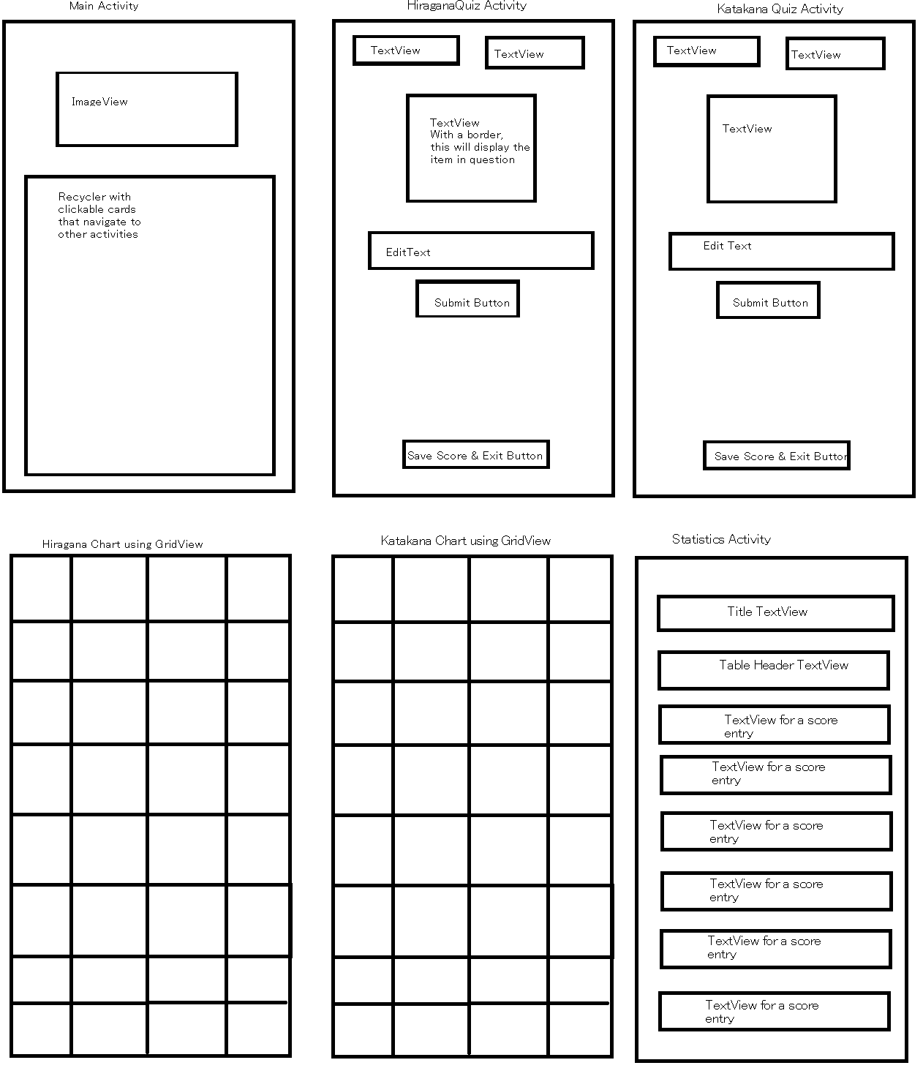

General Activity Flow of Data:

